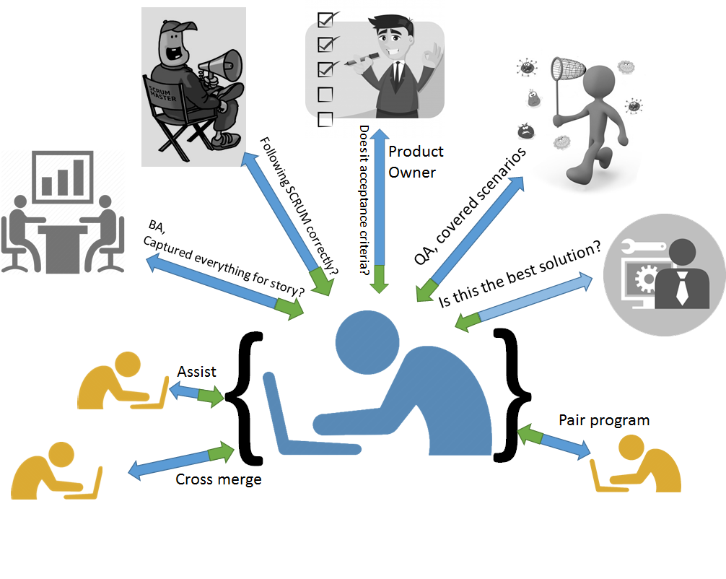

Developers are an integral part of the agile software development process, rather they are the hub. People writing code have to get into this mindset that the whole agile process with scrum methodology is been run on their ability to deliver. Product owners look up to the code whipping machine that you are and your ability to deliver at the end of a sprint

Having said about your position, it’s not just about writing a piece of code block that will make the magic happen. There is a lot more to it, in fact consider yourself as the integral part of the team or that last piece of the giant puzzle which the business is solving. You are not just delivering code but business value as well.

I am writing this post assuming you have already the embraced the agile software development manifesto and are drinking the cool stand up every day! You been part of an agile team are not only cutting away code blocks but you are also liaising, collaborating and banging heads with other peers. Yes you read it right, you will be talking to other people, lots and lots of talking whether it questioning, excel sheeting it or arguing to convince.

Consider this scenario: As a user I want to display a list of friends and suggested friends in a thumbnail view on a webpage.

Interesting it might sound and I can see your nerdy brain drifting away towards …  
“  
if(myfriend) {  
 create_Friends_Grid();  
 apply_default_sort();   
 }  
Else  
 Display_As_Suggested_Friend();

“..

Stop! right there and take a step back. Have you asked/answered these questions?

* How many friends are to be displayed by default? More on request or by default.
* Are friends and suggested friends to be separated?
* How many items per row in the grid?
* What is the size of the thumb nail?
* Theme? Colors? Etc..

All those questions are like a puzzle you have to solve before you jot down some algorithms. You should talk to business/product owner and business analyst about the rules that apply to the friends list, you will talk to the UX about possible ways of displaying the thumbnails, share your solution with your peers and technical lead as well, get the QA to verify different test scenarios you have considered. Everything is making sense now? Looking prettier than your imagination? Good! Now go write that sexy code!

I guess the point I am emphasizing here is before a software developer gets down to their favourite code editor, they should lay down the mat flat and spread out all the pieces, analyse, evaluate and register the key pieces and then start putting them together to have it done in no time, of course meeting all the quality standards. Once you adopt this as a habit, you’ll realise that your output increases and improves at the same time.

Being a software developer myself, I would best summarise it with the quote below and the diagram above also tries to express the same.

“Your ability to deliver is driven off the ability to deliver to yourself “.